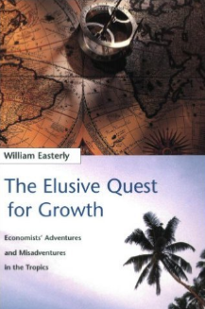 <https://www.amazon.com/Elusive-Quest-Growth-Economists-Misadventures/dp/0262550423>

William Easterly (2002) *The Elusive Quest for Growth*

Footnotes on last page.

Key Question: Which type of entrepreneur (remember there are four types) is Noorul Quader? Explain.

You do not have to, but you can pick more than one if you wish. One page, double-spaced (250 words).

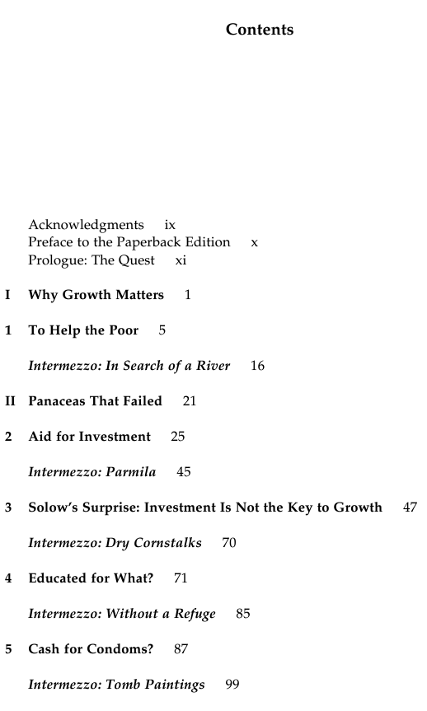 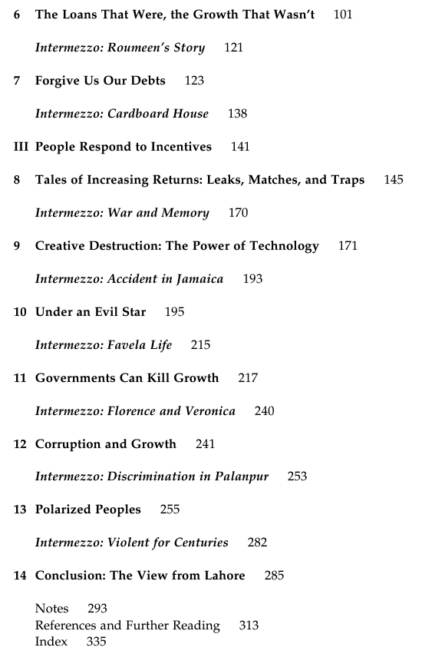

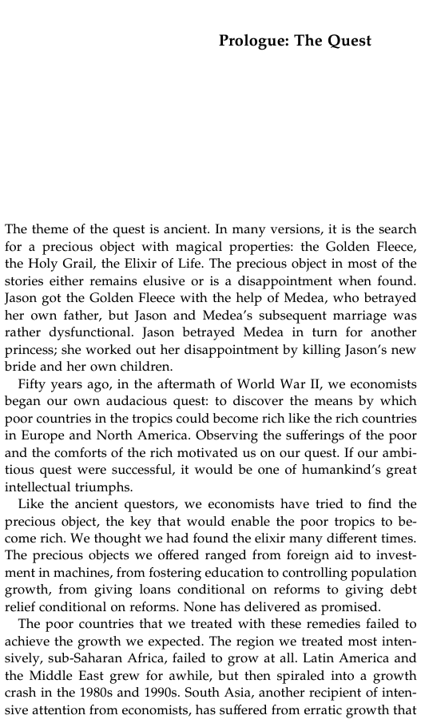

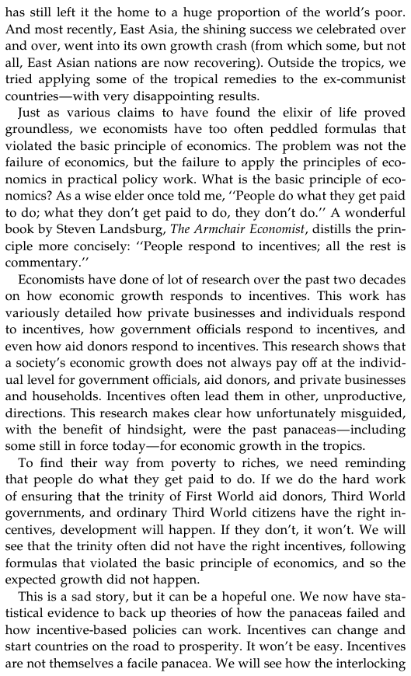

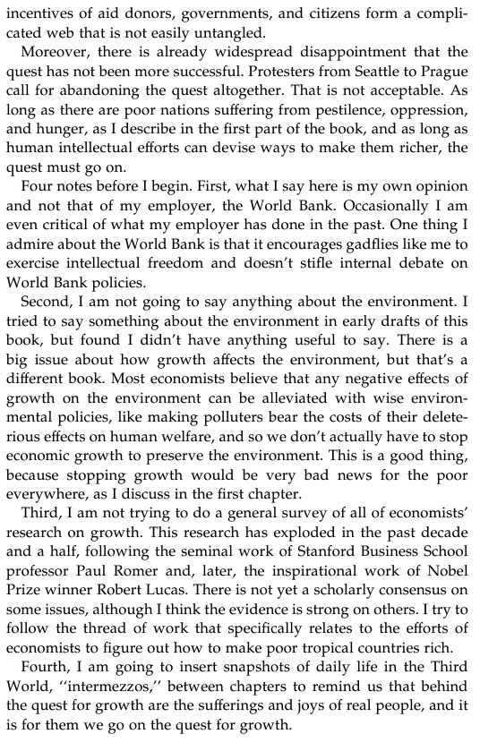

**PART III People Respond to Incentives**

